Rectifying the weakly labeled image for multi-label image annotation using deep neural network (DNN)

THANUJA R

BIGDATA ANALYTICS
SRM UNIVERSITY

CHENNAI, INDIA
thanujahanna94@gmail.com

Abstract

Image Classification is the technique of assigning an input image, particularly labels originating from a predefined set of categories. Image Classification has been a calamity in computer visualization for even as now. Consequently, several people attempted a much diverse approach to resolve this, probably the majority current approach is deep learning. It permits to train the images with the help of Deep Neural Network (DNN) which are readily available in flicker and instagram where such images are weakly labeled with many labels are inaccurately labeled. This algorithm extends the D-NN classifier for multi-label data. In the proposed system, we decided to detect and rectify the imbalanced labeled images by employing an algorithm called DNN (Deep Neural network). In the proposed system, a method is practiced for detecting and analyzing objects in images by using a single shot detector. The ultimate aim of this research work is to gratify the multi-label scenario as well as resolve incorrect labels in the images. The investigation’s outcome of actual web images reveals the efficiency of the future techniques.

Index Terms — Imbalanced labeled image, unlabeled image, DNN, SSD, Weakly labeled image.

- INTRODUCTION

Image classification is perchance the most significant part of the digital picture analysis. The purpose of categorization

SARANYA G

INFORMATION TECHNOLOGY

SRM UNIVERSITY
CHENNAI, INDIA
saranya.g@ktr.srmuniv.ac.in

procedure is to partition and categorize all pixels into particular cover classes. Numerous characteristics pay to the complexity of this problem, together with the huge changeability in appearance. Including this complexity, ordinary images frequently represent various objects than a particular one. In this multi-label scenario, communication among objects, desires to be modeled therefore classifiers can distinguish between co-occurring concepts. Dealing with this issue, typical approaches like deep learning in the convolution neural network is extended to the multi-label case.

The multi-label image is significant as the amount of pictures folks usually upload to social networks such as Instagram and Flicker. DNN is normally feed forward networks that the data is flow through the middle layers.

Recurrent neural networks (RNN) where information may run within several manners which is employed in various areas such as language modeling.

Deep neural networks (DNN) are useful and utilized in the areas of computer vision. DNN is especially used for acoustic
modeling for repeated and automatic speech recognition (ASR).

..
71

We considered an efficient approach to rectify the weakly labeled image which is known as multi-label image annotation in deep learning. We precisely develop an algorithm to work with multi-label images which are incorrect or unlabeled. It permits to train the DNN to study characteristics by manipulating data from imbalanced labeled images.

Deep Neural Network (DNN) contains many deep neural layers and then pursues various completely linked neural layers as in standard multilayer neural network. The architecture of a deep neural network is intended in acquiring the improvement of the 2D arrangement (2D contribution known as a speech signal). This is accomplished with links and fixed weights. DNN is simpler to train which is considered as the main advantage and has the smallest quantity of the parameters than fully associated networks with the matching number of the unknown part.

II. RELATED WORKS

Image classification is a considerable task in computer vision. The multi-label learning approach known as ML-KNN is accessible and its results obtained in established k-nearest neighbor (KNN) algorithm. For every example, k-nearest neighbors are initially recognized. Maximum a posteriori (MAP) principle is the neighboring instance used to find out the label position for the new illustration [9]. Additionally, to allocate appropriate labels to picture is a biased substance, particularly while several images can divided into many classes repeatedly. Image processing in Multi-label annotation mainly seen in the predicament where every picture can contain many labels. So it is called time-consuming and expensive when the images are labeled manually. So in order to decrease individual attempt of labeling images, mainly in the images of multi-label, a multi-label active learning in

support vector machine technique is introduced [6]. Through active learning is widely considered and studied on diminishing labels attempt to single-label problems, proposed research on active learning remains in a beginning state. A label cardinality inconsistency strategy and max-margin prediction strategy are the two novel active learning, multi-label strategies to assimilate them into an adaptive structure of multi-label active learning [8].

Deep convolution neural networks (CNN) have revealed an immense achievement in image classification, so significant real-world images normally include numerous labels, which could communicate with various attributes, objects, actions and scenes in an image [1]. CNN compact with multi-label images which is a complex problem, especially inadequate images [4]. Hypotheses CNN-Pooling framework is used to compact with the multiple image classification problem. Depending on the proposed system, deep neural networks pre-trained in single label large quantity of datasets. Adding together, featured HCP necessitate bounding box annotation which is needed to train the images and can be effortlessly acclimatized to multi-label datasets [3]. There is always growing attention in multi-label image classification because of its significant role in web-based and image analytics-based applications such as browsing and large-scale image retrieval. In recent times matrix completion (MC) has been initiated as a technique for weakly labeled multi-label classification and has various dissimilar advantages which include strength and toughness to missing data and environment noise in label space [7]. Most of the techniques for optical recognition are usually supervised but pixel-wise segmentation and bounding boxes are used to position objects of interest. Manual labeling is one of the types which is always time consuming, error prone and revealed that manual segmentations are not necessarily finest enclosed space which is useful for object classifiers. In this condition, trained pictures are interpreted with the group of various

71..

images are interpreted with the set of various keywords that describes the contents, excluding visual concepts, are not overtly subdivided in the images [2]. Multi-label image information is becoming omnipresent. Image semantic recognized as typically formulated categorization problem which is focused on multi-label in active learning for image classification. It first widens conventional example related active learning technique for multi-label image classification. So the conventional example related active learning technique has not performed well. So a novel example based multi-label in active learning method is proposed [5].

III. FLOW DIAGRAM
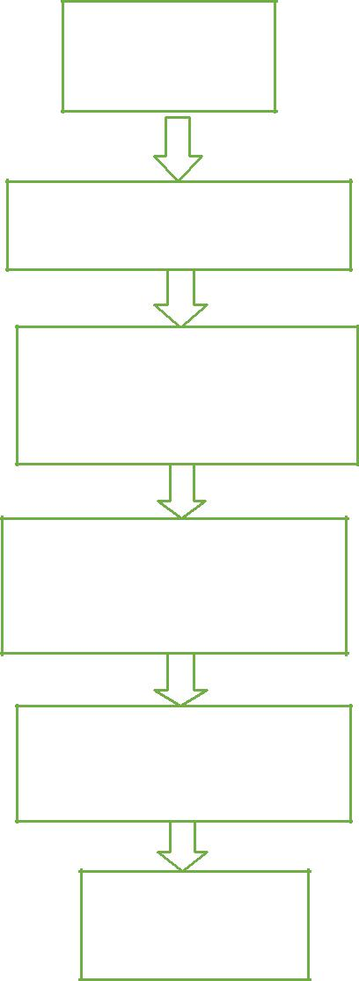

DATASET

IMAGES

IV. SINGLE SHOT DETECTORS

A technique for detecting and analyzing objects in images using a single deep neural network. An approach called SSD, discrete the yielding of bounding boxes into a deposit of the default boxes in excess of different characteristic scales and ratios. At prediction period, the network produces scores for every object group in every default box and generates adjustments to the boxes to be the best match the object figure and shape.

The SSD approach is depended on a feed-forward deep convolution network which generates a fixed-size group of bounding scores and boxes for the occurrence of object class illustration in individual boxes, pursued by a non-maximized repression way to generate the final detections.

V. PROPOSED RESEARCH

RESIZE ALL IMAGES

INTO 100*100 PIXELS

DIVIDE THE DATASET
INTO TEST AND

TRAINING IMAGES

TRAIN ALL DATASETS
WITH DNN AND

EXTRACT REGION

COMPUTE CNN
FEATURES AND

CLASSIFY REGIONS

IMAGES
LABELLED
ACCURATELY

Fig.1. A flowchart diagram for rectifying the weakly labeled image for multi-label classification.

Deep learning is one of the important categories of techniques that study numerous levels of images and representations that converse to several points of ideas and abstraction which forms a hierarchy of conception. It also utilizes a flow of several layers of non-linear processing parts for feature mining and conversion. Deep learning uses few types of gradient descent for training during the backpropagation. Classification is a model for supervised learning and pattern analysis is an example of unsupervised learning. Layers are employed in deep learning that contains unseen layers of an artificial neural network and they can also comprise underlying variables, structured layer-wise in deep generative representation like the nodes in Deep Boltzmann machines and the deep belief network. Deep Learning methods are useful to unsupervised learning responsibilities. It is considered as the significant advantage because weakly labeled data are more plentiful than labeled data. Examples of a deep network can be qualified and trained in an unsupervised way.

..
73
Most foremost approach for confronting and to contract with the multi-label categorization problem is convolution neural networks in deep learning.

Deep Convolution Neural Networks are related to regular Neural Networks and so they are developed by neurons with weights and biases. Each neuron accepts a number of inputs that works as a dot product. Neural networks usually has a loss function like SVM and Softmax scheduled the layer which means fully-connected layer.

Deep neural network is considered as best approach or algorithm to multi-label annotation in the field of image processing. The weakly labeled images are predicted initially and then rectified followed by processing of feature extraction and pre-processing. So weakly labeled images are reduced by an employing neural network algorithm in deep learning approach.

Deep-learning networks implement spontaneous feature abstraction without social intervention, unlike maximum traditional machine-learning algorithms. A deep-learning framework qualified and trained on labeled information or data can then be given to unstructured data, sharing its access to abundant input when compared to machine-learning nets. This is a method for higher performance: the additional data a network can able to train on, the more precise it is likely to be. (Ruthless algorithms qualified on plenty of data or information can outperform best algorithms trained on actual.) Deep learning’s capability to practice and process from the enormous amount of unlabeled data provides it a distinct improvement over earlier algorithms.

 |  | Labels |  |  |  |  |  |  | Deep
(A) TRAINING |  |  |  |  |  |  |  |  | Learning
 |  |  |  |  |  |  |  |  | Framework
Input |  |  |  |  | Pre- |  |  | Feature | Framework
Image |  |  |  | Processing |  |  |  | Extraction
(B) TESTING
 |  |  |  |  |  |  |  |  | Deep
Input |  |  |  |  | Pre- |  |  | Feature | Convolution
Image |  |  |  |  | Pre- |  |  | Feature | Neural
 |  |  |  | Processing |  |  |  | Extraction | Neural
 |  |  |  |  |  |  |  | Extraction | Network
 |  |  |  |  |  |  |  |  | (DNN
 |  |  |  |  |  |  |  |  | Classifier)
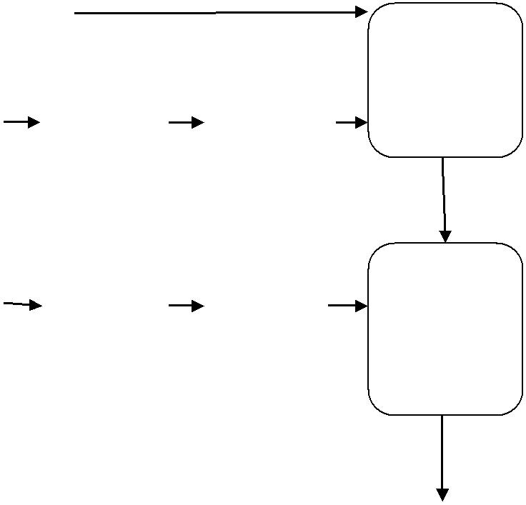

Rectifying
the Weakly
Labeled
Image

Fig.2. This work proposes incorrect labeling to multi-label image classification. Train sets images (a) labeled correctly and test images (b) incorrectly labeled images rectified by a deep neural network

V. MULTI-LABEL IMAGE CLASSIFICATION

A. MULTI-LABEL K-NEAREST NEIGHBOR

Multi-Label k-Nearest Neighbor (ML k-NN) is a lazy learning approach or technique which stores all accessible cases and classifies new cases that depend on a similarity measure [9]. In KNN categorization, the outcome is a class membership. In this kind of case, the input is comprised of the K nearest neighbor (KNN) training examples in the feature space. By training the available data set with KNN algorithm is used to identify and discover the similar objects available in the dataset and also help us to predict and rectify the weakly imbalanced labeled images using various preprocessing methods.

..
74
- Support vector machine (SVM)

In machine learning, supervised learning models associated with related learning methods which evaluate data or information are employed both for regression and classification analysis. The main suggestion or idea of this algorithm is to acclimatize extreme margin approach to contract with multi-label image data or information, wherever a group of linear classifiers is utilized to moderate the empirical ranking loss [9]. Hence support vector machine is considered as one of the finest machine learning approaches for image classification. SVM classifies the labeled image into relevant and irreverent labels in the images.

C. Deep neural network

A deep neural network, which is also called as convent is a class of deep, feed-forward (ANN) artificial neural networks that have been related to analyze and evaluate visual or illustration imagery. A deep neural network (DNN) is one of the networks with numerous unseen layers in the centre. Related to one-dimensional neural network, DNN can represent multifaceted non-linear relationships. The deep neural network plays a vital role in image processing. DNN is used to classify multiple objects in an image and is also used to rectify the weakly labeled image. deep neural networks (DNN) are applied even in computer vision.

TABLE I Comparison between Multi-Label Classification Techniques

Sr.no | Methods | Pros |  | Cons
1 | ML-KNN | Imbalanced |  | Label correlation
 |  | issues | are | is not possible.
 |  | reduced.
2 | SVM | Linear |  | The | Large
 |  | classification. |  | labeled | Dataset
 |  |  |  | cannot | Be
 |  |  |  | handled.
3 | CNN | Used for | multi- | Some of missing
 |  | label | image | labels | are not
 |  | classification. |  | found.

VI. DEEP LEARNING FRAMEWORK

Deep learning which is also called as deep feature learning is the family of machine learning and technique related to information illustration, as different to task-related algorithms. Deep learning architectures like recurrent neural network and a deep neural network is useful in various areas such as audio recognition, computer visualization, speech recognition, social network filtering etc.., where they manufactured outcomes similar to the human experts.

The hypothesis underlying dispersed representations are that experimental data are produced and created by the interactions and connections of layered features. Deep learning assists to extricate this concept out and choose which features develop performance. Deep learning attaches the statement that these layers of partially communicate to levels of generalization or composition unreliable sizes can afford dissimilar ideas. Deep learning methods can be employed for unsupervised tasks. This is a significant advantage due to unlabeled data are further profuse than labeled data. Deep neural networks are normally used in approximation theorem. Feed forward neural networks are usually combined with a particular unssen layer of limited range to estimate unremitting purpose.

VII. WEAKLY LABELED IMAGE ANNOTATION

There are an enormous number of images which is obtained on the web. In the recent development of multi-label images, weakly labeled images are identified and corrected using various algorithms in both machine learning and deep learning techniques. Image classification requires many labels to define the single picture with actual significance and more labels generally work mutually with one another in semantic space.

75..

A new method is used to calculate numerous labels for pictures and to afford labels for several objects contained in the image. Weakly labeled image framework are the images with little group of the accessible images which is labeled and also in the labeled picture, the known labels are normally inaccurate and incorrect.

A weakly-labeled dataset contains only images which are unlabeled sets that include Meta data and information that grasp each image inside a set.
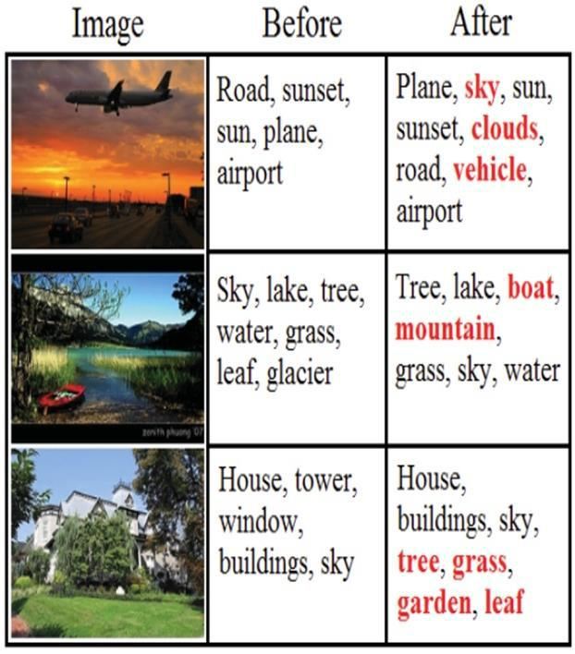

Fig.3. Missing label vector is figured out in multiple images.

Basically, the dataset contains only "unlabeled" data, but there is at least some meta-information is used to categorize your data. Thus, the information in this data is less informative when compared to the labeled data and information, but it is not zero.

VIII. IMAGE RECOGNITION USED IN DEEP LEARNING

Image recognition was used in computer vision and is considered to be the most common estimation for image categorization is the COCO data set. COCO is the dataset that contains of 60,000 training instances and 10,000 test instances. Users experiment with numerous configurations in the dataset called COCO. An inclusive list of consequences and outcomes are offered. Deep learning-related image recognition or detection has happened to be “superhuman", fabricate more correct consequences than the human competitor.

IX. METHODS USED IN MULTI-LABEL IMAGE CLASSIFICATION

A. Optical character recognition

In 1930, Emanuel Goldberg established "Statistical Machine" for examining microfilm documents and libraries using an optical code recognition system. Optical character recognition is used in pattern recognition. It is used to recognize each character in the text which is contained in an image in the form of handwritten text into machine-encoded text.

X. TRIPLET LOSS

Triplet loss is a metric learning technique which is widely applied in many applications. For instance, image retrieval, person re-identification and face recognition. A triplet normally contains three samples: an anchor sample, a positive one by means of the similar class to the anchor and a negative one integrated with the dissimilar class. The intention of triplet loss is to determine a metric that shifts forward the optimistic pair nearer, while pulling the negative pairs missing, thus tests within the analogous class that can be adjoined to each other.

76

IMAGES BATCH

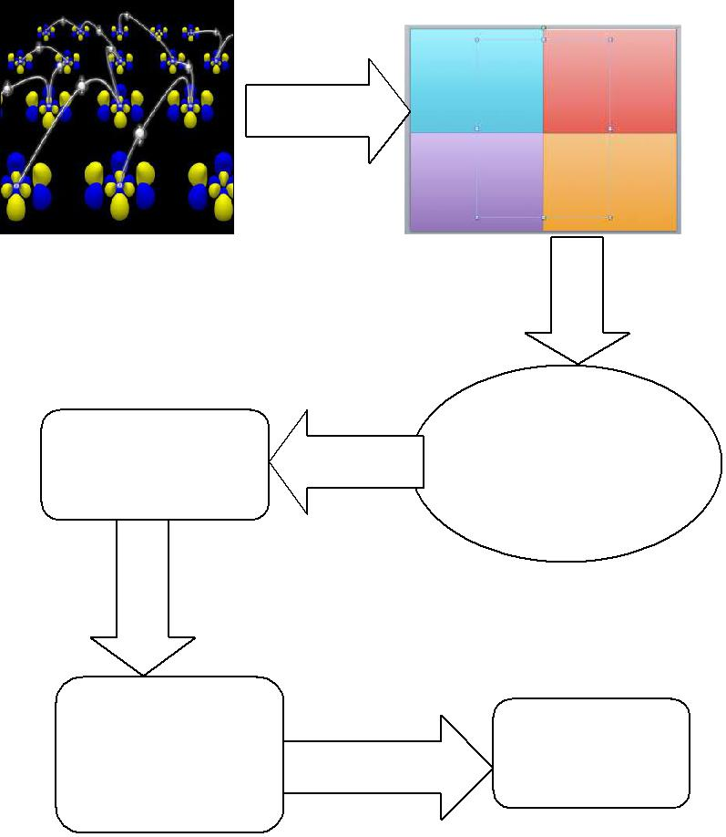

 | DEEP
EMBEDDED | CONVOLUTION
EMBEDDED | NEURAL
 | NETWORK

TRIPLETS | TRIPLET LOSS
Fig.4. The pipeline of training

IX. FEATURE EXTRACTION

When the input information is added to a technique is too enormous to be handled and it is expected to be terminated afterward the input information will be changed into a condensed demonstration set of characteristics also known as character vectors. Exchanging input data into the collection of characters and properties is known as feature extraction.

- Edge detection

Edge detection involves range of arithmetical technique which aims in recognizing positions in a picture with intensity and clarity. The very first step in the method is to execute some type of edge detection on the image and to produce an innovative Binary edge image that affords the essential segmentation of the original image. The position at which image intensity adjust are normally ordered in curved line section known as edges. Edge detection is one of the basic feature extraction used in image processing and computer vision mainly in the areas of feature detection and feature extraction.

B. Blob detection

The blob detection technique is focused on detecting areas in a digital picture that may change in various characteristics, such as shape, intensity and color to surrounding areas. These areas could signal the occurrence of objects or division of objects in the image field with application to object recognition and object tracking. Normally, blob is a area in which numerous features are mostly stable and all the points which is contained inside the blob are equivalent to each other. The most well-known technique for blob detection is called convolution.

C. Thresholding

Thresholding is considered as one of the best method of image categorization. It usually converts the gray scale image into binay images. Color images know how to be the threshold. One approach is to allocate and delegate a divide threshold for each of the RGB mechanism of the image and then merge them with an AND operation. This replicates the mode the camera works and how the data and the information

77
are stocked in the computer, but it does not match to the manner that people identify the color. Therefore, the HSL and HSV color representation is most often utilized, but note hue is a spherical quantity it needs circular thresholding.

- Hough Transform

Hough Transform (HT) is the robust techniques in feature extraction for discovering lines in images. Hough Transform was first developed by Paul Hough. Hough transform is the technique of feature extraction used in image analysis. The reason for the technique is to identify an imperfect example of objects local maxima in a so-called accumulator space that is overtly created by the algorithm for figuring out the Hough transform. The conventional Hough transform was concerned with the finding of lines in the image, but later the Hough transform has been general to identify the arrangement of arbitrary shapes, most ordinary circles or ellipses.

TABLE II

The characteristics of two datasets used in our experiments
Datasets | Domain | Instances | Labels
Flicker | Images | 200 | 6
Facebook | Images | 200 | 5

algorithm called convolution neural network. We estimate to tain the images with deep neural network that is contained in the dataset called COCO containing 1000 images. Hence the ground-truth of 20 conceptions contained in the COCO dataset can be estimated for valuation, so we concentrate on the entire 20 concepts in experiments. The experiment mostly depends on NUS-WIDE-SUB. We focus on estimating and calculating our technique when the numerous amounts of weakly labeled images are very much lesser than unlabeled ones. Hence we arbitrarily divide the multi-label images into the 20% division for training and the 80% division for testing.

TABLE III Precision and recall

Method | Training | Precision | Recall
SVM | 200 | 82.4 | 82.2
KNN | 200 | 88.5 | 87.3
DNN | 300 | 98.7 | 98.4

Precision and recall are then described as:

Precision = tp

tp + fp

Recall = tp

TABLE II: The images are taken from the flicker and Facebook datasets. In flicker images, they are 650 instances and 6 labels. In Facebook images, they are 240 instances and 5 labels.

XII. EXPERIMENTAL RESULTS

- Implementation details

All of our experiments and models are executed in Python. We trained all of our models by employing a deep learning

tp + fn

The terms positive and negative known as the classifier's prediction or expectation and the terms true and false known to whether that prediction match up to the outer judgment.

Recall is also called as the true positive rate or sensitivity, and precision is also known as positive predictive value (PPV).

..78

True negative rate = tn

tn + fp

Flicker

Accuracy = tp + tn

tp + tn + fp + fn

A related measure utilized and applied in image classification includes accuracy. A true negative rate, which is contained in this case, is called as specificity.

- Results and discussions

Example 1:

Multi-label classification

INPUT IMAGE

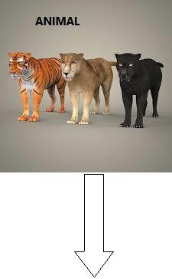

OUTPUT IMAGE

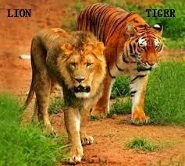

Fig.5. The images are taken from the flicker datasets. The input image consists of a set of objects which are labeled as animals. The output object consists of a set of objects which are labeled accurately as lion and tigers using proposed techniques.

TABLE IV

Datasets | Domains | Class | Subclass | Labels
 | Images | Furniture | Chair, Table | 2
Facebook | Images | Animals | Lion, Tiger | 2

Table IV: Lion and tiger are the sub-class taken from the class animals and it is labeled correctly using proposed techniques. Chairs and Tables are the sub-class taken from the class Furniture and it also labeled correctly using proposed techniques.

XIII. CONCLUSION

We proposed a deep learning framework which selects instance recognized on their objects content and determines the cost of increasing the information. Recently, most of the folks desired to have a discussion or conversation using multimedia data, information and facts as an alternative to text communications. Image retrieval is calculated to be added interesting assignment on the web. Weakly labelled images from flicker and instagram can be trained using deep neural networks which comes under unsupervised learning learning are rectified creatively with the advent approach of a capable single shot detector method. Research results have recognized its supremacy concluded the existing systems. Feasible power for practical applications with noisy data and information in a smaller amount time with elevated accuracy.

ACKNOWLEDGMENT

We thank our faculty members from SRM University who afforded insight and knowledge that greatly assist and contribute our research work.

79

REFERENCES

- Jiang Wang, Yi Yang, Junhua Mao, Zhiheng Huang, Chang Huang, Wei Xu. CNN-RNN: A Unified Framework for Multi-label Image Classification, 2016.

- Ricardo Cabral, Fernando De la Torre, João P. Costeira, Alexandre Bernardino. Matrix Completion for Weakly-supervised Multi-label Image Classification, 2012.

- Yunchao Wei, Wei Xia, Min Lin, Junshi Huang, Bingbing Ni, Jian Dong, Yao Zhao. HCP: A Flexible CNN Framework for Multi-label image

Multi-label Image Classification, 2015.

  - Yunchao Wei, Wei Xia, Junshi Huang, Bingbing Ni, Jian Dong, Yao Zhao, CNN: Single-label to Multi-label,2014.

  - Jian wu, victor s.sheng, jing zhang, pengpeng Zhao,Zhiming Cui.Multi-label classification for image processing,2014.

  - X.Li, L.Wang, E.Sung, Multi-label svm active learning for image classification, 2004.

- Ricardo S. Cabral Fernando De la Torre, João P. Costeira, Alexandre Bernardino, Matrix completion for multi-label image classification.

[8]Min-Ling Zhang and Zhi-Hua Zhou, A k nearest neighbor based algorithm for multi-label image classification, 2005.
[9]Xin Li and Yuhong Guo, Active learning with multi-label image classification, 2013.

[10] Y. Gong, Y. Jia, T. Leung, A. Toshev, and S. Ioffe, “Deep convolutional ranking for multilabel image annotation,” 2012

- Y. Yang, F. Wu, F. Nie, H. Shen, Y. Zhuang, and A.

Hauptmann, “Web and personal image annotation by mining label
correlation with relaxed visual graph embedding,” IEEE Trans.
.
- Erin L. Allwein, Robert E. Schapire, and Yoram Singer,

“Reducing multiclass to binary: A unifying approach for margin classitiers,” Joicniul of Mucltine Leorrrirry Research. vol. 1. pp. 113-141.Dec2000.

- Erin L. Allwein, Robert E. Schapire, and Yoram Singer, “Reducing multiclass to binary: A unifying approach for margin correlation with relaxed visual graph embedding,” IEEE Trans. Image Process., vol. 21, no. 3, pp. 1339–1351, Mar. 2012.

- Y. Han, F. Wu, Q. Tian, and Y. Zhuang, “Image annotation by input-output structural grouping sparsity,” 2012

- C. Steven, R. Michael, and R. Jin. Integrating user feedback log into relevance feedback by coupled svm for content-based image retrieval. Data Engineering Workshops, pages 1177–1186, 2005

- M. Guillaumin, T. Mensink, J. Verbeek, and C. Schmid,

“Tagprop: Discriminative metric learning in nearest neighbor models For image auto-annotation,” in Proc. IEEE 12th Int. Conf. Comput.
Vis., 2009, pp. 309–316.

- SI S. Tong and D. Koller, “Support vector machine active learning with applications to text classification.” Joirmal of Machine

Lmming Research. vol. 2, pp. 4546. 2001. 161

- R. Yan. J. Yang. and A. Hauptmnnn. “Automatically labeling video data using multi-class active learning,” in The 9111 lnternatiortul Conference on Compiirer Visioi~. 2003. pp. 516-523

- He, J., M. Li, Z. Li, H. Zhang, H. Tong and C. Zhang, 2004. Pseudo Relevance Feedback Based on Iterative Probabilistic One-Class SVMs in Web Image Retrieval. Proc. Pacific-Rim Conf. Multimedia.

- A. Fakeri-Tabrizi, M. R. Amini, and P. Gallinari, “Multiview semi supervised ranking for automatic image annotation,” in Proc.
ACM Int. Conf. Multimedia, 2013, pp. 513–516.

- A. Makadia, V. Pavlovic, and S. Kumar, “A new baseline for image annotation,” in Proc. Eur. Conf. Comput. Vis., 2008, pp. 316–

329.

  - C. Campbell. N. Cristianini, and A. Smola. “Query learning with large margin classifiers,” in Proceeding. Of111e 171h [22] M. Stricker and M. Orengo. “Similarity of color images,” in Pmrrrdinps of SPlE Slorage mil Rrrrieenl for lmagr and Video Databases, 1Y95, pp. 381-392.

80..

